S2_IOT

Check your data breaches S2 IOT
Check
your data breaches
Monday, May 11, 2026
3:16 PM
Created with OneNote.
================================================================================

Collection & use of personal info S2 IOT
Collection
& use of personal info
Wednesday, April 22, 2026
3:48 PM

Australian Privacy Principle 5 (APP
5): Notification of Collection of Personal Information
Australian Privacy Principles Principle 5 explains that
organisations must inform people when collecting their personal information.

Main Requirement of APP 5
When an organisation collects personal information, it must:
- notify the individual at the
time of collection, or as soon as possible afterwards
- make sure the person
understands why the information is being collected and how it will be used

Information That Must Be Provided
The organisation must tell the individual:
- the organisation’s identity
and contact details
- if information was collected
from another source
- why the information is being
collected
- whether collection is
required by law or a court order
- what may happen if the person
does not provide the information
- who the information may be
shared with
- how the person can access or
correct their information
- how to make a privacy
complaint
- whether the information may
be sent overseas
- which countries may receive
the information, if known

Example
A school collecting student enrolment details must explain:
- why the data is needed
- who can access it
- how it will be stored
- whether it may be shared with
other organisations
Created with OneNote.
================================================================================

Dependency of society upon electronic communication for business S2 IOT
Dependency
of society upon electronic communication for business
Wednesday, April 22, 2026
3:49 PM
Created with OneNote.
================================================================================

Digital divide S2 IOT
Digital
divide
Wednesday, April 22, 2026
3:49 PM
Created with OneNote.
================================================================================

Electronic commerce (Ecommerce) S2 IOT
Electronic
commerce (Ecommerce)
Wednesday, April 22, 2026
3:49 PM
Created with OneNote.
================================================================================

IOT (1) S2 IOT
IOT
Monday, May 11, 2026
9:13 AM
Created with OneNote.
================================================================================

Implications of identity theft S2 IOT
Implications
of identity theft
Wednesday, April 22, 2026
3:48 PM

Identity Theft – What Can Happen
If someone gains access to your identity, they can:
- Apply for a credit card
- Open bank accounts
- Apply for loans or financial
services
- Build up debt in your name
- Claim government benefits
- Apply for a driver’s license
- Register a vehicle
- Apply for jobs
- Apply for a passport
- Set up mobile phone contracts

How Identity Theft Happens
Loss or theft of important documents:
- Passport
- Driver’s license
- Poor handling of personal or
sensitive data

Risks of Misusing Sensitive
Information
- Discrimination
- Emotional harm (humiliation,
embarrassment)
- Damage to personal dignity

Signs You May Be a Victim of Identity
Theft
- Unknown transactions on
bank/credit card statements
- Told you are already claiming
government benefits
- Receiving bills for things
you didn’t buy
- Being denied credit despite
good history
- Phone contracts opened
without consent
- Contact from debt collectors
for unknown debts

Support & Information
- Australian Competition and
Consumer Commission (ACCC)
- Scamwatch
These services provide:
- Updates on scams
- Advice on identity crime
Created with OneNote.
================================================================================

Privacy Act
Privacy
Act
Wednesday, April 22, 2026
3:31 PM
Created with OneNote.
================================================================================

Summary of the Australian Privacy Principles (APPs) with Example Breaches
Summary
of the Australian Privacy Principles (APPs) with Example Breaches
Tuesday, May 12, 2026
8:16 AM
Created with OneNote.
================================================================================

Syllabus (1)
Syllabus
Wednesday, April 22, 2026
2:54 PM
Created with OneNote.
================================================================================

The impact of social networking technologies on traditional methods of information publication and di
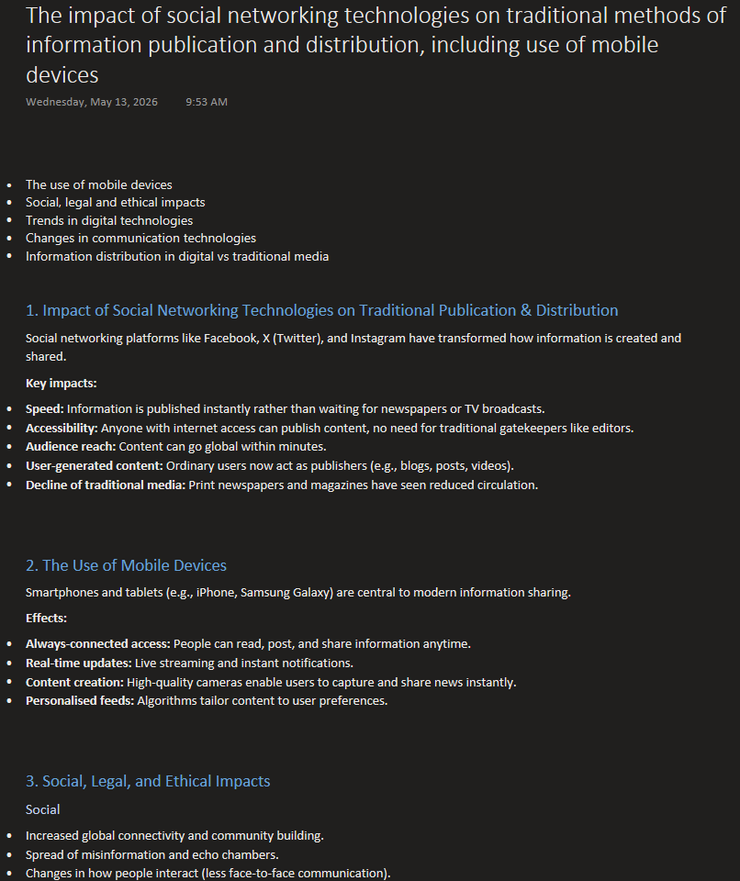

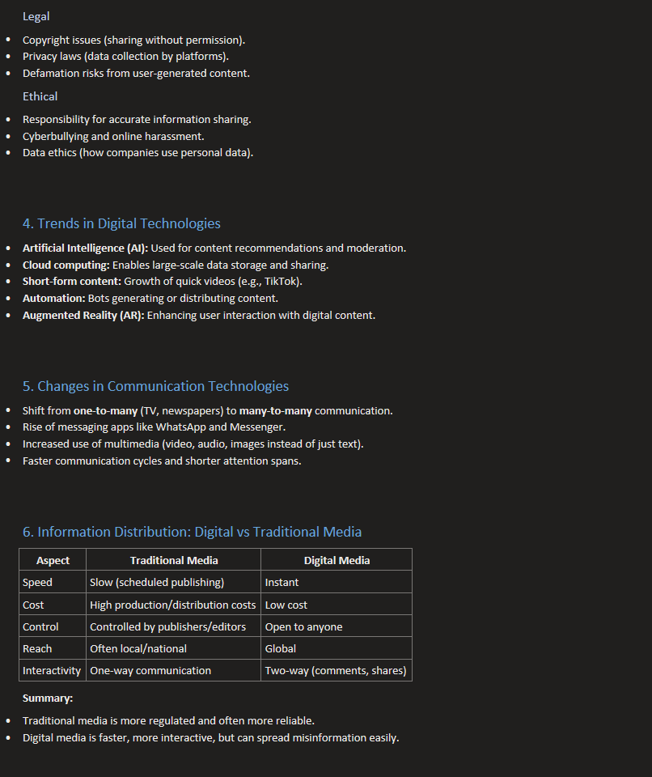



Created with OneNote.
================================================================================

